Basavarajeswari group of Institutions

BALLARI INSTITUTE OF TECHNOLOGY

& MANAGEMENT, BALLARI

**“JnanaGangotri" Campus, No.873/2, Ballari-Hospet Road, Allipur, Ballari-583104 (Karnataka State)** 2021-2022



**C++ PROJECT LAB-2021-22**

**A Mini-Project Report On**

**“SALES MANAGEMENT SYSTEM”**

**A project work designed and developed as a part of**

**C++ PROJECT LAB**

**For the Academic Year 2021-22**

Project Associates:-

|  |  |  |
| --- | --- | --- |
| **SL NO** | **NAME** | **USN** |
| **1.** | **SAI AJAY** | **3BR20CS174** |
| **2.** | **SANKET NAIK** | **3BR20CS147** |
| **3.** | **UTKARSH KUMAR** | **3BR20CS173** |
| **4.** | **VARUN B** | **3BR20CS178** |

BALLARI INSTITUTE OF TECHNOLOGY AND MANAGEMENT

(AN AUTONOMOUS INSTITUTION UNDER VISVESVARAYA TECHNOLOGICAL UNIVERSITY BELAGAVI)

“JNANAGANGOTRI” CAMPUS, No.873/2, BALLARI-HOSPET ROAD ALLIPUR, BALLARI-583104(KARNATAKA)

**DEPARTMENT OF COMPUTER SCIENCE ENGINEERING**

Certificate

This is to certify that **Sai Ajay , Sanket Naik ,Varun B and Utkarsh Kumar** bearing USN: **3BR20CS174, 3BR20CS147, 3BR20CS178 and 3BR20CS173** respectively has satisfactorily completed a Mini-Project on topic entitled **“Sales Management System”** as a part of Skillup C++ of the fourth semester BE in Computer science engineering during the academic year 2021-22.

# Signature:

**SHREESHAILNATH**

**Assistant Professor**

Computer science engineering

**TABLE OF CONTENTS**

|  |  |  |
| --- | --- | --- |
| **S.N** | **TOPIC** | **PAGE NO.** |
| **1.** | **INTRODUCTION** | **4** |
| **2.** | **ABSTRACT** | **5** |
| **3.** | **OBJECTIVES** | **6** |
| **4.** | **FLOW CHART/ ALGORITHM** | **7-8** |
| **5.** | **FUNCTIONALITY** | **9** |
| **6.** | **FEATURES** | **10** |
| **7.** | **FUTURE SCOPE OF THE PROJECT** | **11** |
| **8.** | **LIMITATION** | **12** |
| **09.** | **RESULT** | **13-18** |
| **10.** | **CONCLUSION** | **18** |
| **11.** | **REFERENCES** | **19p** |

**INTRODUCTION**:-

Sales management is defined as the planning, direction, and control of personal selling including recruiting, selecting, equipping, assigning, routing, supervising, paying, and motivating as these tasks apply to personal sales force.

Sales management originally referred exclusively to the direction of the sales force. Later the term took on broader significance in addition to the management of personal selling.

Sales management spe­cifically contributes to achieve the marketing objectives of a firm. In fact, sales managers set their personal selling objectives and formulate the personal selling policies and strategies.

The word sales management is a combination of two words- sales and management. Sales is the art of planning in the mind of another a motive which will induce favourable action. The committee of American Marketing Association has defined it as- “Selling is the personal or impersonal process of assisting and or persuading a prospective customer to buy a commodity or a service or to act favourably upon an idea that has commercial significance to the seller.”

**ABSTRACT:-**

In this project based research an effort has been made to explore the different aspects of Sales management along with Management Information System. Various dimensions of the scope of sales related Management System have been studied in this project. Initiative has been taken to explore the field where competent management can comply properly.

The key task of this project is to be sensitized and familiarized with Management concepts and its effect on Sales Management System of relevant Company. In this project it has been tried to build a uncomplicated multidimensional Database Management System. It has also been tried to make an analytical Processing Cube with a view to illustrate how to utilize Sales Management System software.

OBJECTIVES:-

The main purpose of Sales management project is to provide user friendly and fast working environment to the end users for sales and purchase. This project is computerized the manual process of any sale and purchase related work in the company, Sales Management System is a generalized system developed for handling all the work of any sale and purchase organization. Some of the main features of this system are as follows

→This is a PC based VBO project.

→The whole system is menu driven with all work can done with simple clicks

→Sales Management System provides facility of add edit and delete details of customer, dealer, items, sales and purchase orders

→This system also works as inventory management such as item details, stock management etc .In this project any individual record can be searched by giving its ID.

FLOW CHART:-

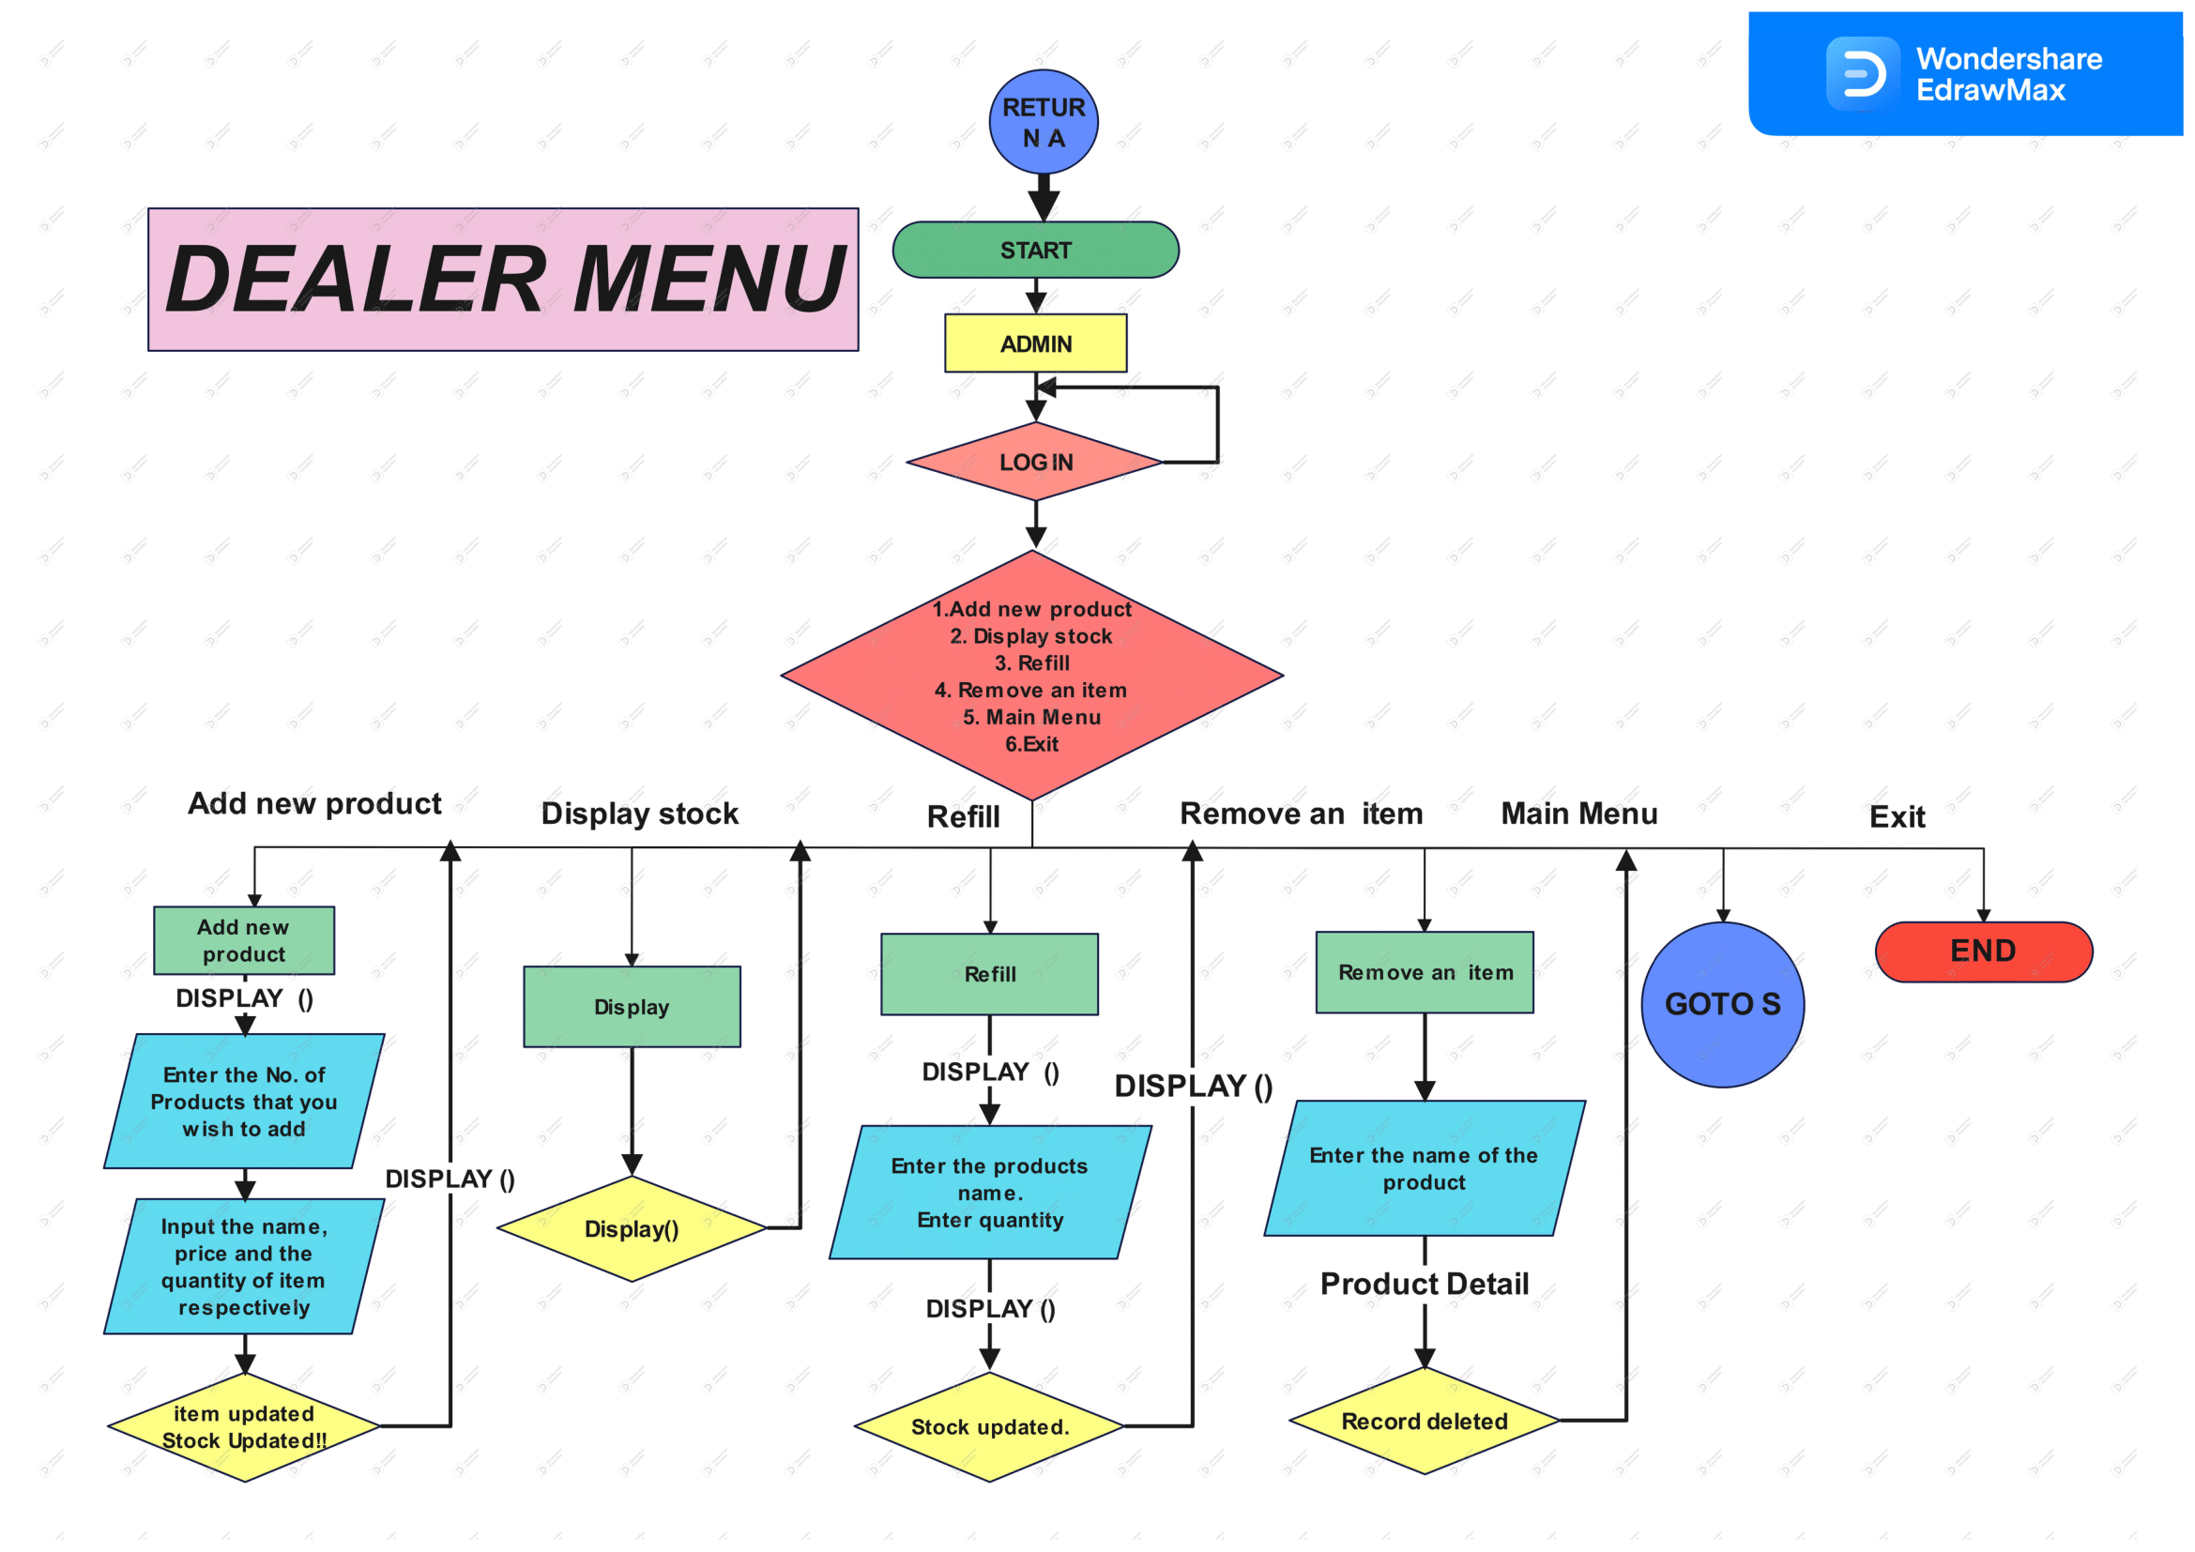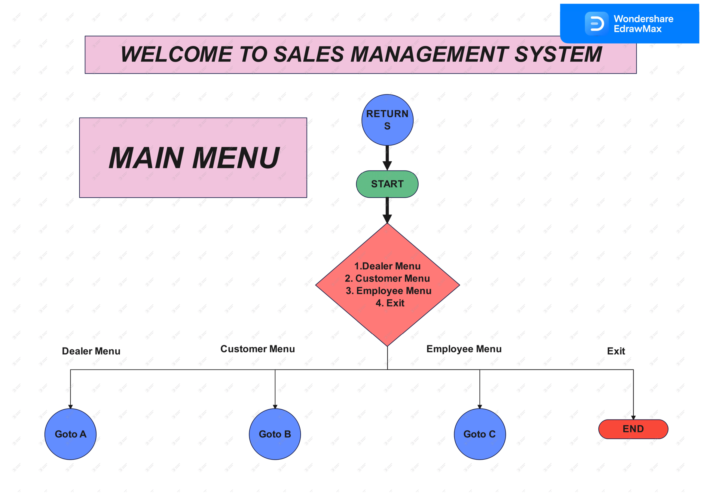

# 

# 

# Functionality:-

### Previous Performance and Setting Target

### Managing the Sales Process

### Improving process efficiency

### Monitor sales progress & performance

### Get detailed reports on sales

# Features:-

# 1. User login

# 2. Add/Edit Unit

# 3. Add/Edit Product

# 4. Sales order

# 5. Purchase order

# 6. Sales report

# FUTURE SCOPE OF THE PROJECT:-

# This system helps in tracking past sale records. This system makes billing process very fast. This system developed in such a way that any user having little knowledge about computers can operate this software. This system provides high level security from unauthorized access. Each user has a different login id and password. Each record can be verified for any error.

# It is the sales management that helps the organization in achieving its objectives and goals. Sales management takes care of the product’s price and releases so that they can earn a profit as well as cost useful for the users. In this way, both the buyers and sellers can develop a healthy business relationship as well. It is a sales manager who carefully understands the requirements of the customers directly and tries to maintain the business relationship through the proper exchange of products.

[The sales manager’s scope rules over the following roles.](https://www.slideshare.net/Fuckboy123/sales-and-inventory-management-system-project-report" \t "_blank)

* [The sales manager develops new sales strategies with proper plans and objectives for the overall sales team.](https://www.slideshare.net/Fuckboy123/sales-and-inventory-management-system-project-report" \t "_blank)
* [It is the sales manager who mentors and monitors the sales team.](https://www.slideshare.net/Fuckboy123/sales-and-inventory-management-system-project-report" \t "_blank)
* [Sales management is the field that reviews all the past and the current sales and marketing information.](https://www.slideshare.net/Fuckboy123/sales-and-inventory-management-system-project-report" \t "_blank)
* [Sales managers analyze the competitors market policies and try to develop new goals for the upliftment of his/her company.](https://www.slideshare.net/Fuckboy123/sales-and-inventory-management-system-project-report" \t "_blank)

**→** Limitations of the system**:-**

The system does not cover functionalities such as generation of financial statements or balance sheets, report on the salaries of sales agents, compatibility with E-commerce (online purchases and payments) and cross platform compatibility (it is windows based). The generation of financial statements or balance sheets is meant purposely to differentiate the sales system from the accounting system and remove the extra functionality which most SME’s hardly need or require.

* Sales Management information system is a desktop based project. It can not run over the internet
* In this project before start billing any new product its detail must be first saved in the product master and similar process in case of new customer, dealer etc.
* This product dose not has bar code facility so it can not be used as Point Of Selling.

**RESULT**

**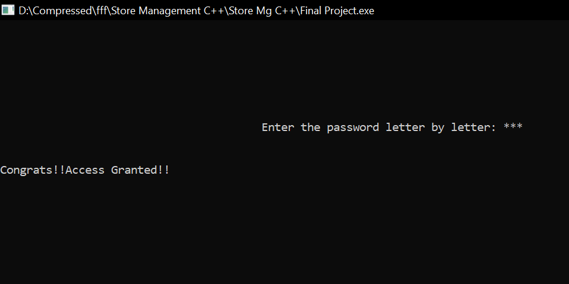**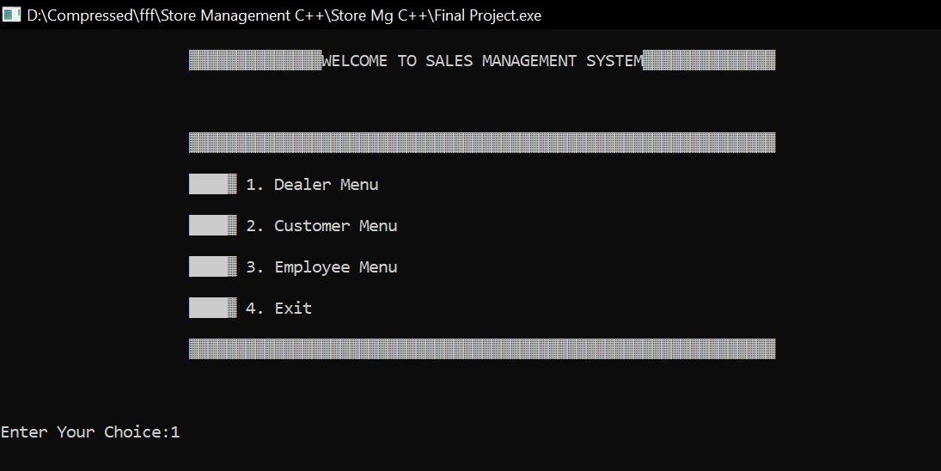 **1.Main Menu: 2.Dealer Menu Login**

Fig:1 Fig:2

**3.Add New Product 4.Display Available Stock**

**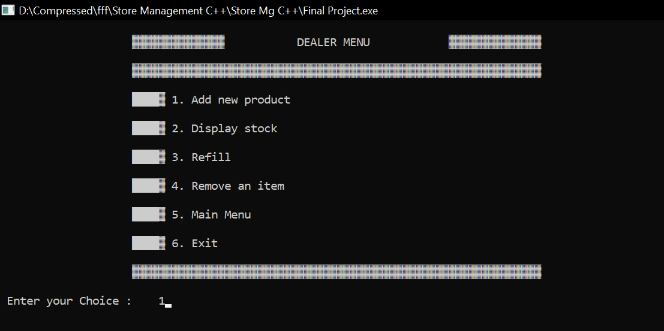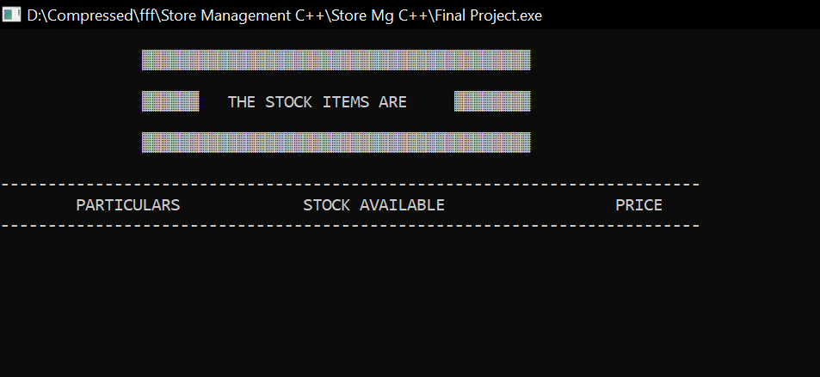**

Fig:3 Fig:4

**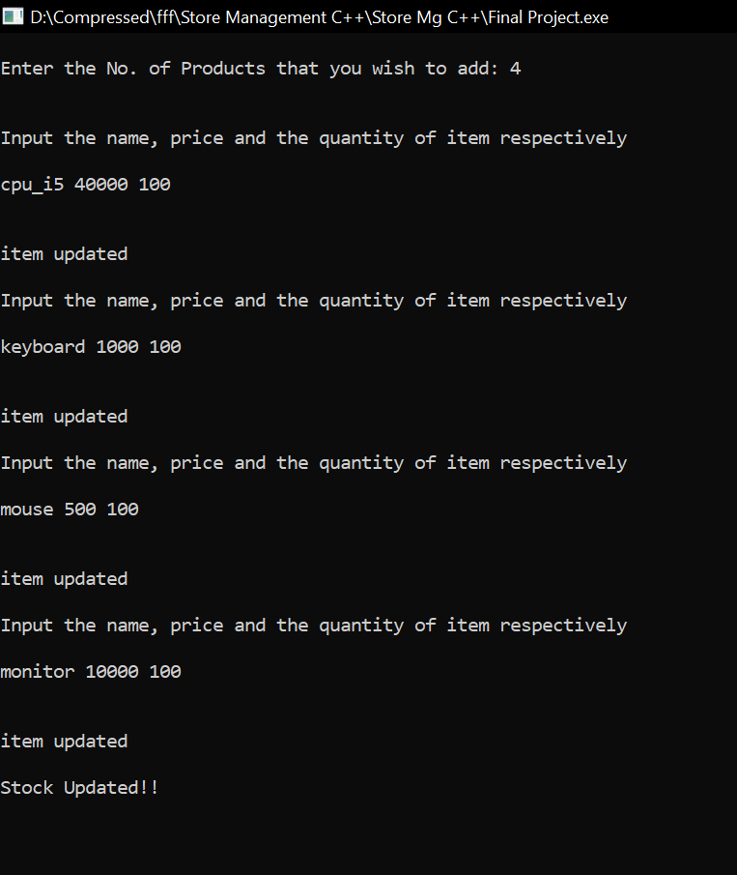5.Adding Product**

**6. Display Available Stock**

**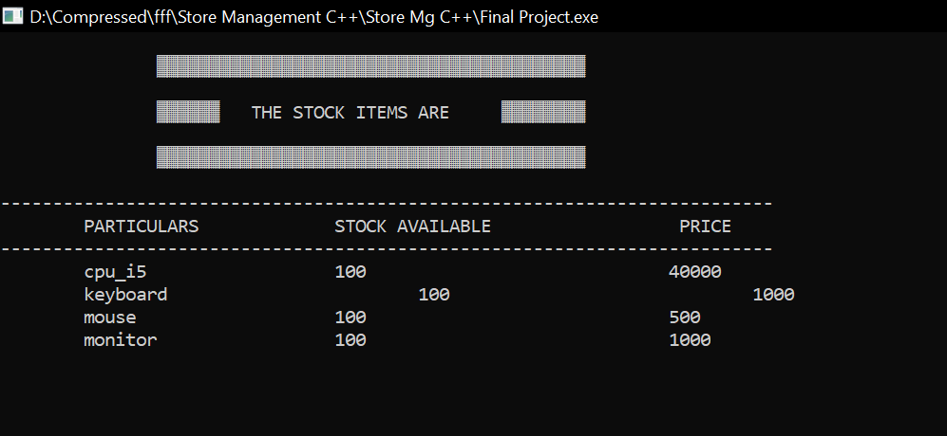**

Fig:6

Fig:5

**7.Display Option 8. Display Available Stock**

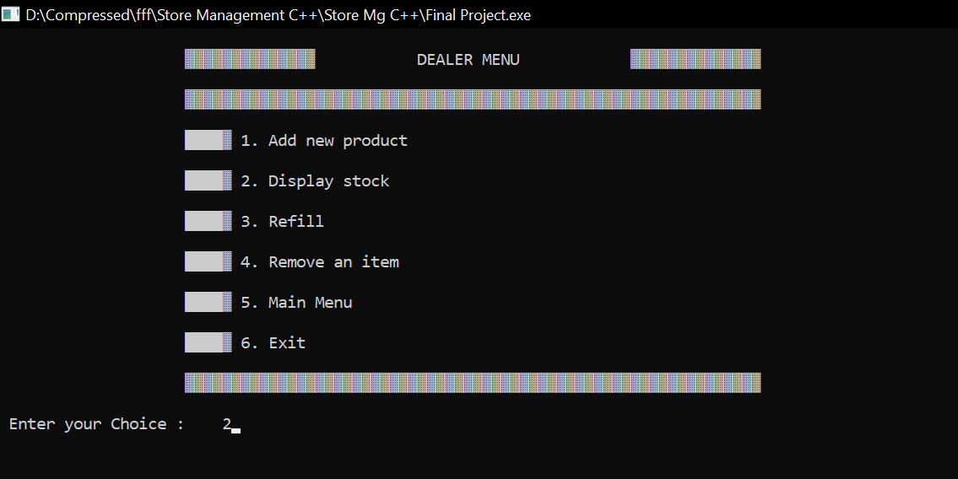

Fig:7 Fig:8

**9.Refil The Stock 10.Stock Update**

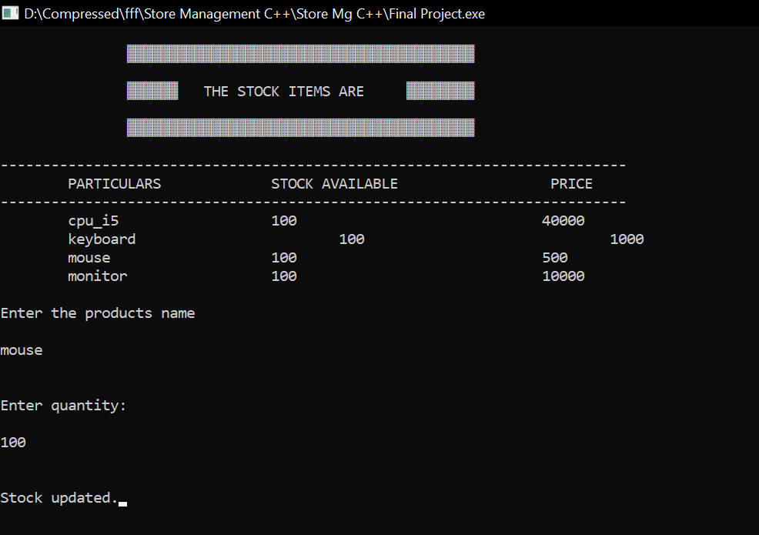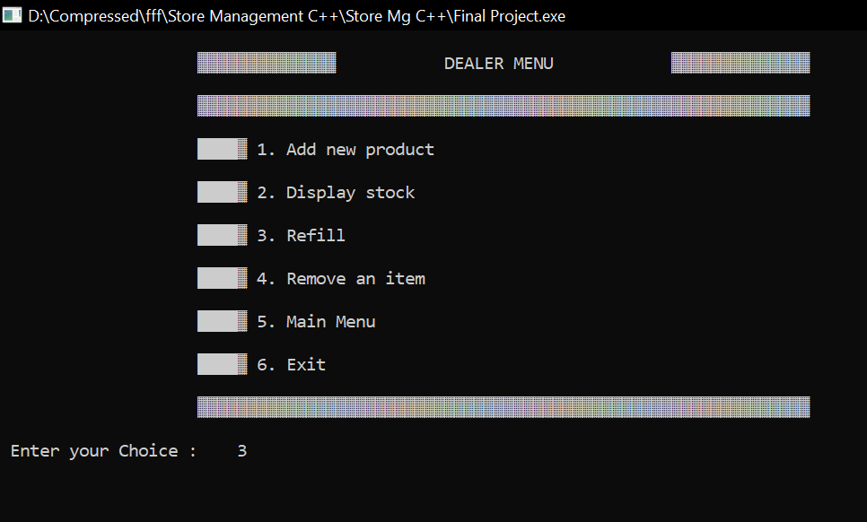

Fig:9

Fig:10

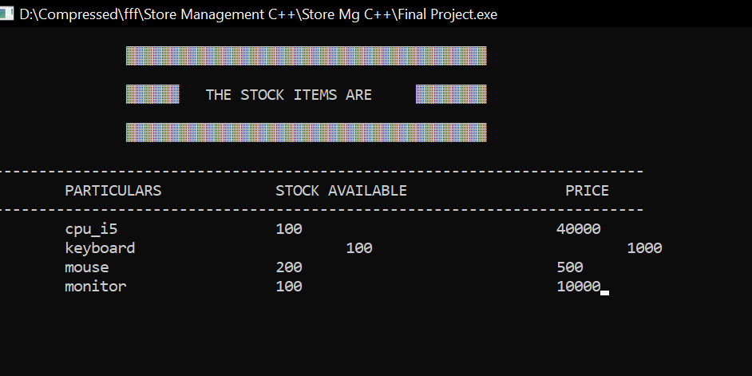 11. **Display Available Stock**

**12.Remove an Item**

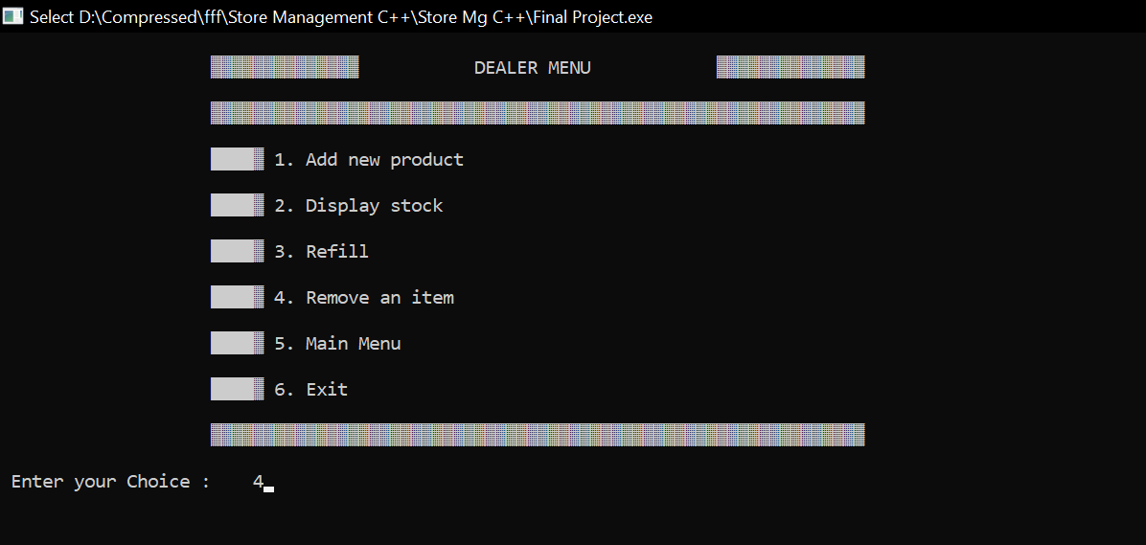

Fig:11 Fig:12

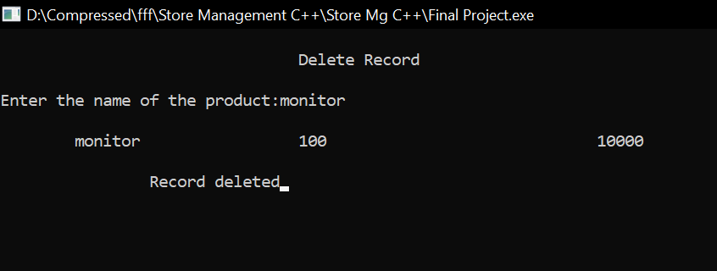 13.Stock Delete 14. If Press 5 in Dealer Menu then

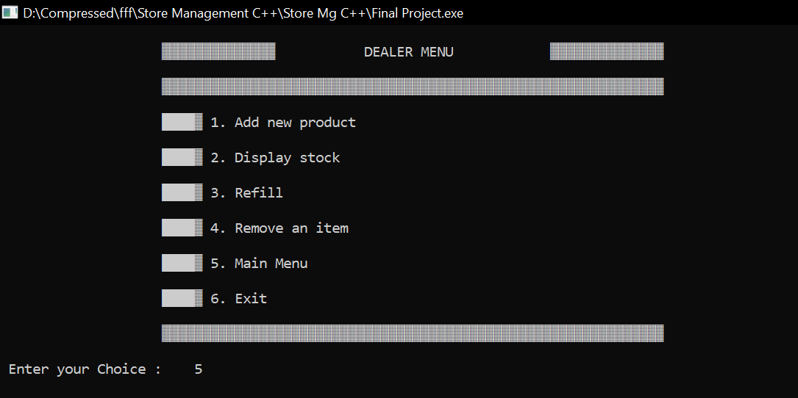

Fig:13 Fig:14

15.Main Menu 16.If Press 6 in Dealer Menu then

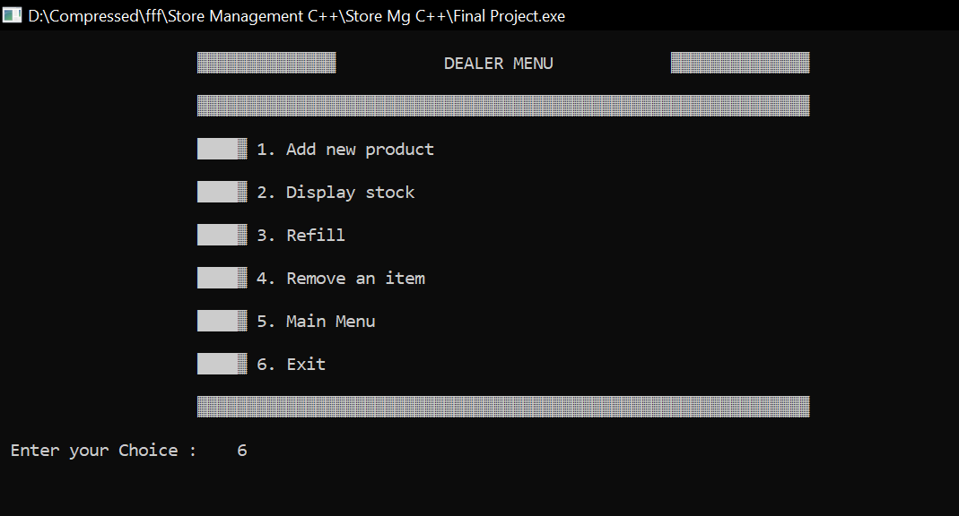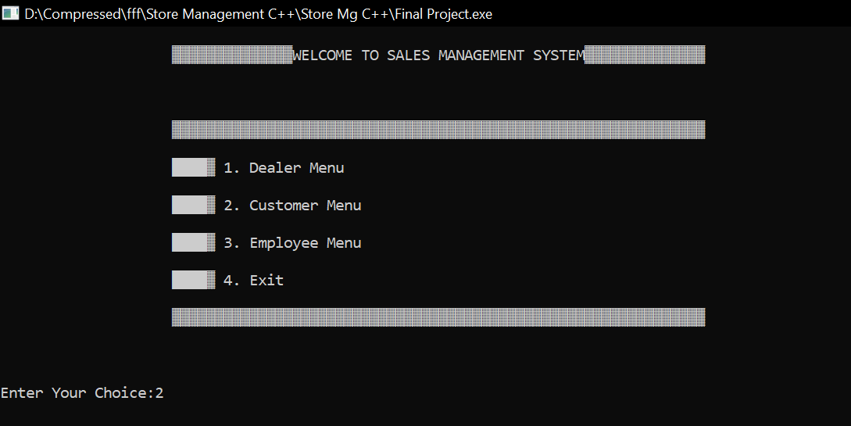

Fig:15 Fig:16

17.Exit from Program 18. If Press 2 in Main Menu then

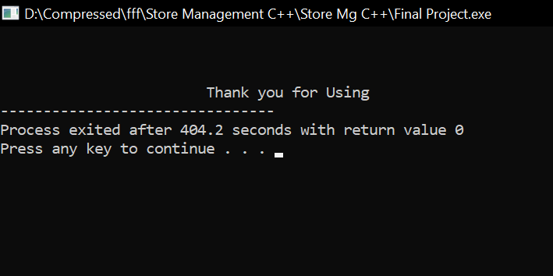

Fig:17 Fig:18

19.Customer Menu 20.Purchase Item

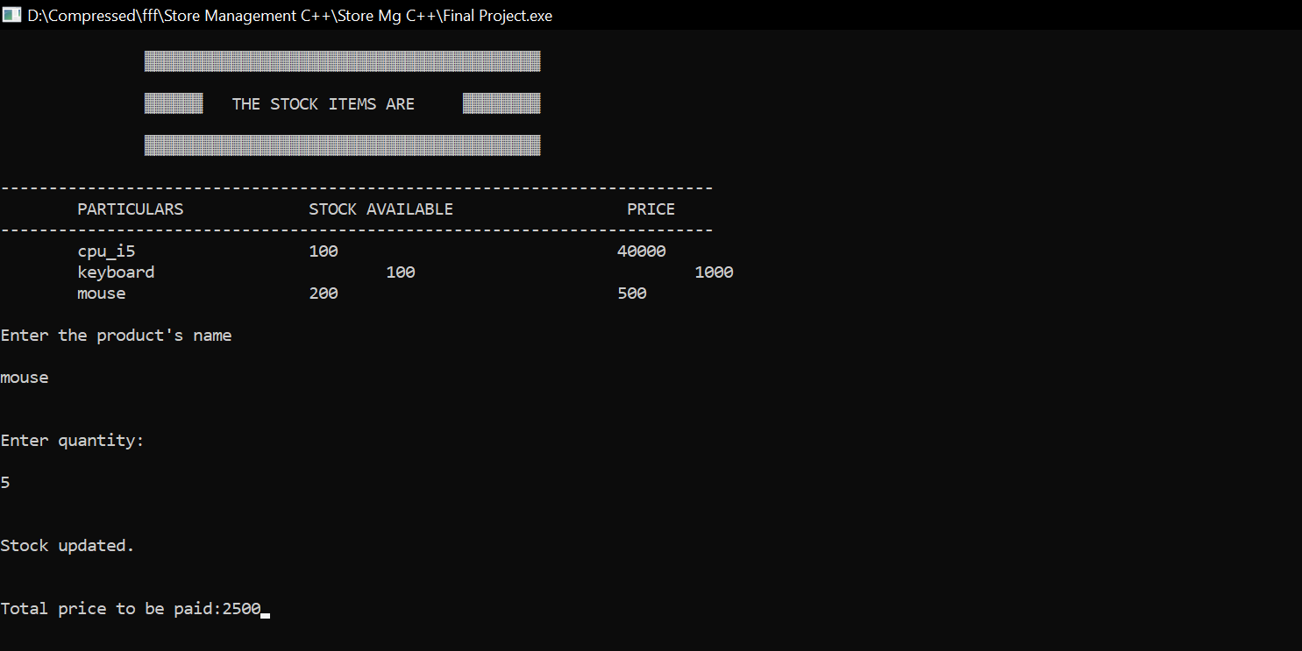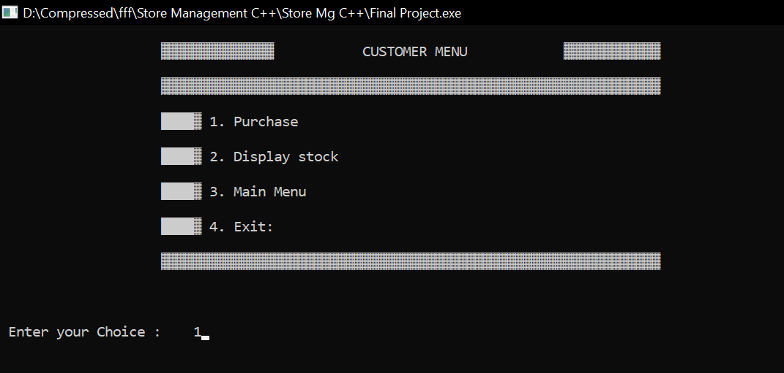

Fig:19 Fig:20

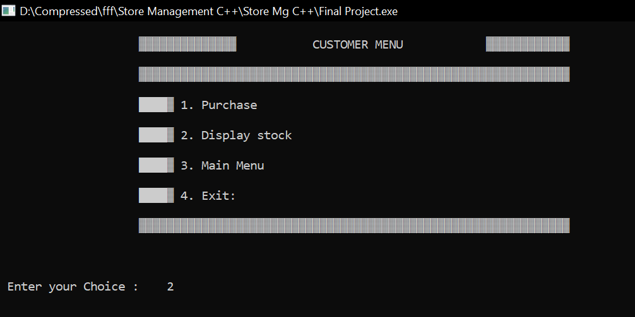**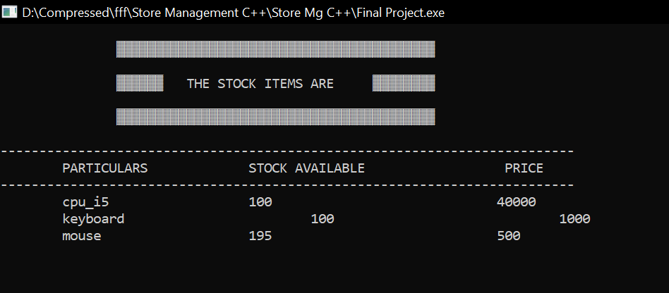21.Display Available Stock 22.Display Stock**

Fig:21 Fig:22

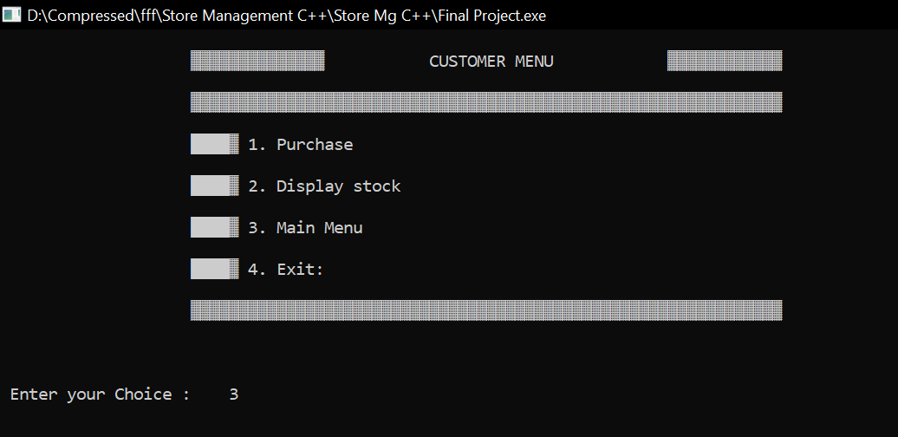**23.Display Available Stock 24.** If Press 3 in Customer Menu then

Fig:23 Fig:24

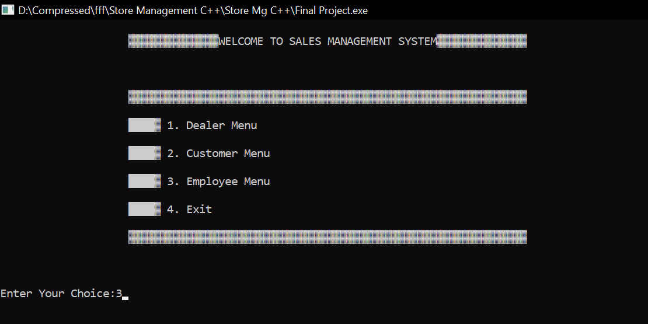 25.Main Menu 26. If Press 4 in Customer Menu then

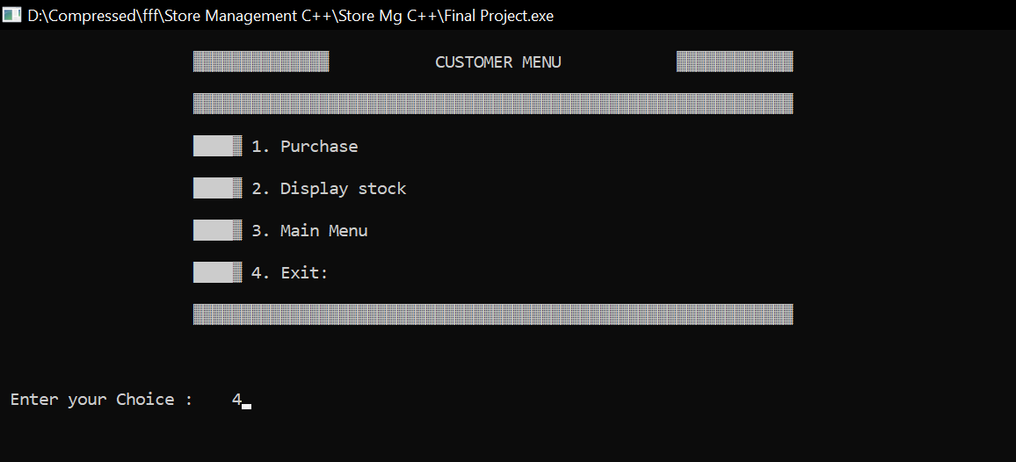

Fig:25 Fig:26

27.Exit 28.If Press 3 in Main Menu then



Fig:27 Fig:28

****

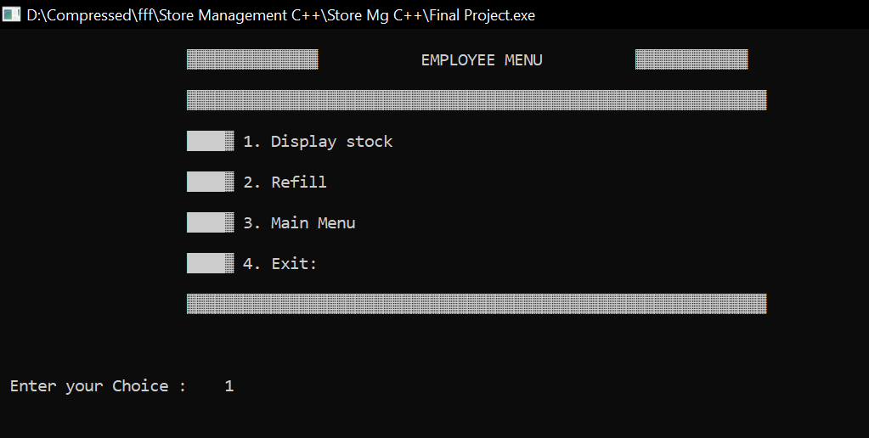

Fig:29 Fig:30

Fig:29 Fig:30

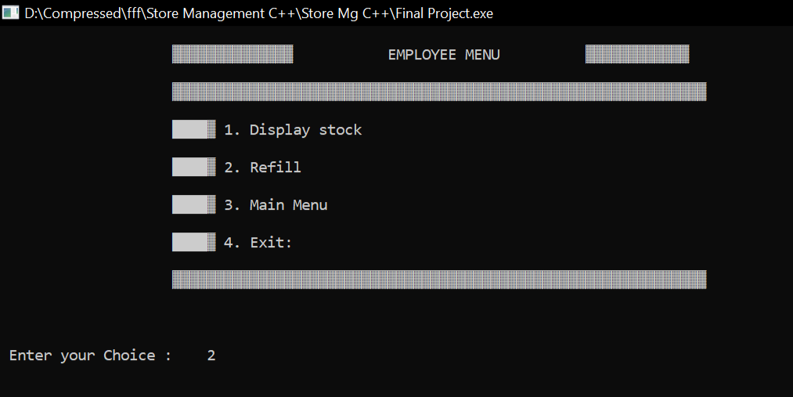

Fig:31 Fig:32

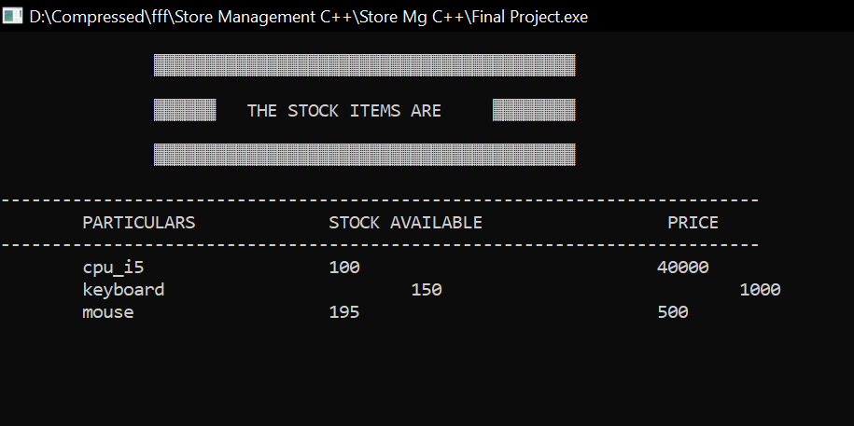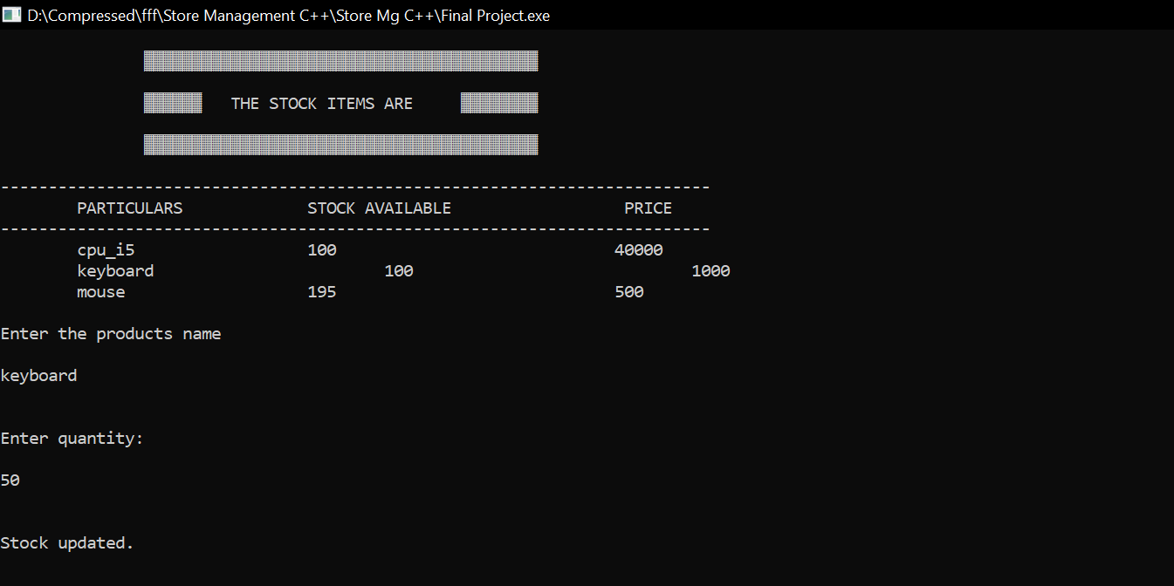

Fig:33 Fig:34

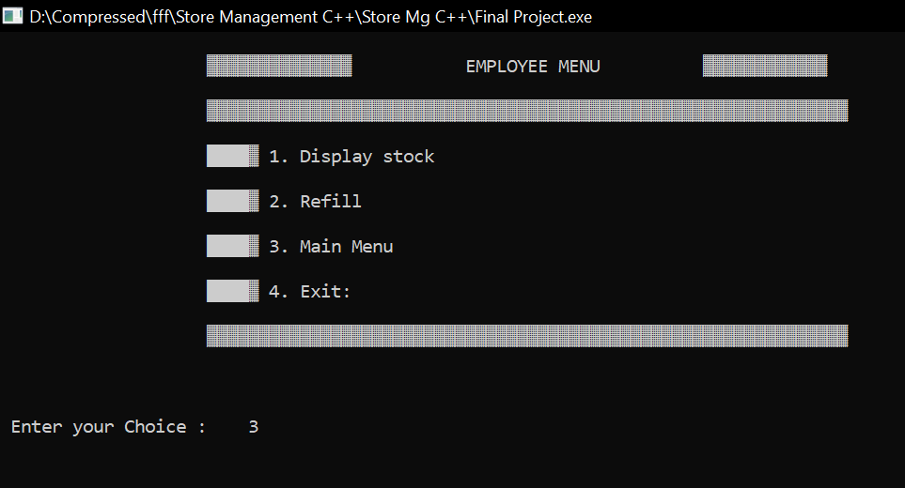

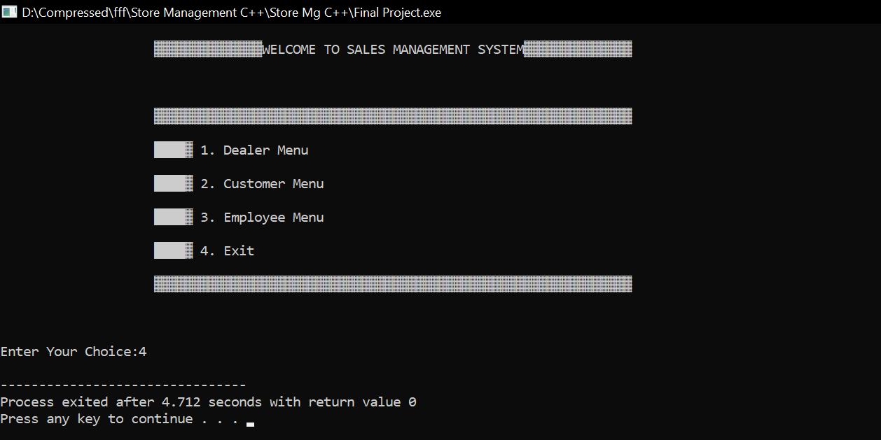

Fig:35 Fig:36

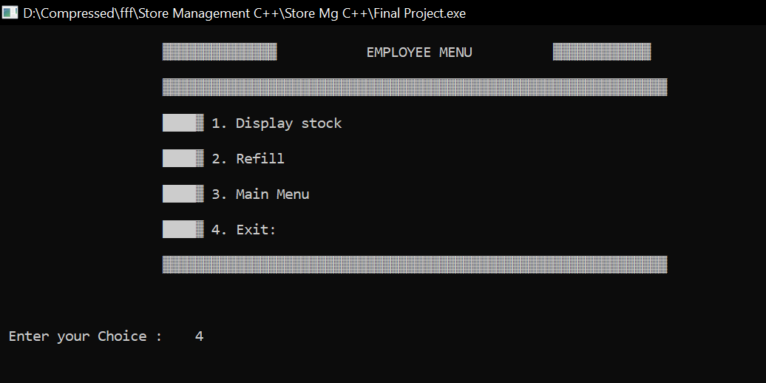



Fig:37 Fig:38



Fig:39

**CONCLUSION:-**

The success of any system is dependent on its usage. It is therefore hoped that the system will be used under conditions that satisfyits requirements. Given the required maintenance, the system will help facilitate sales management by tracking and storing relevant data needed for effective sales management.

**REFERENCES:-**

1. Mahesh Bhave and Sunil Patekar, "Programming with Java", First Edition.

2. Herbert Schildt, The Complete Reference C++, 4th Edition.

3. Stanley B.Lippmann, Josee Lajore, C++ Primer.

4. Rajkumar Buyya,S Thamarasi selvi, xingchen chu, Object oriented Programming with java.

5. Richard A Johnson, Introduction to Java Programming and OOAD.

6. E Balagurusamy, Programming with Java A primer.